To share file or directory between ubuntu and mac with UTM.

Allow file share and remot login in system prefercenses on mac

System prefercenses->sharing-> file sharing and remot login

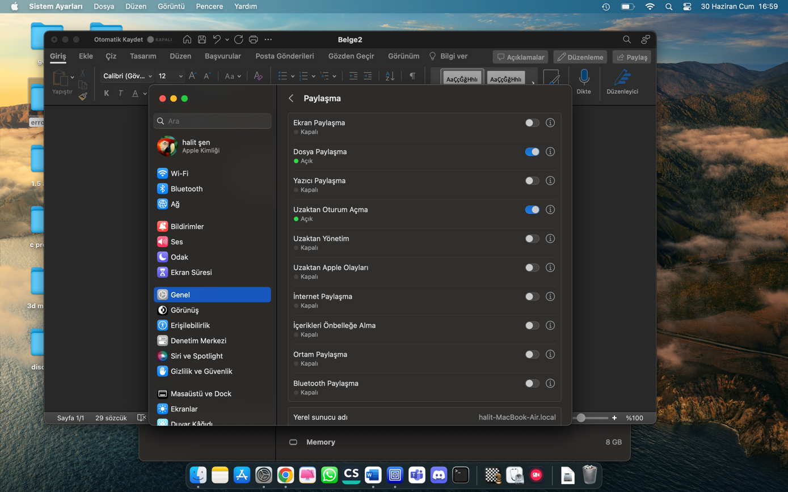

And open UTM ubuntu

Go to home->other location

And clik username-macbook(remot-login)

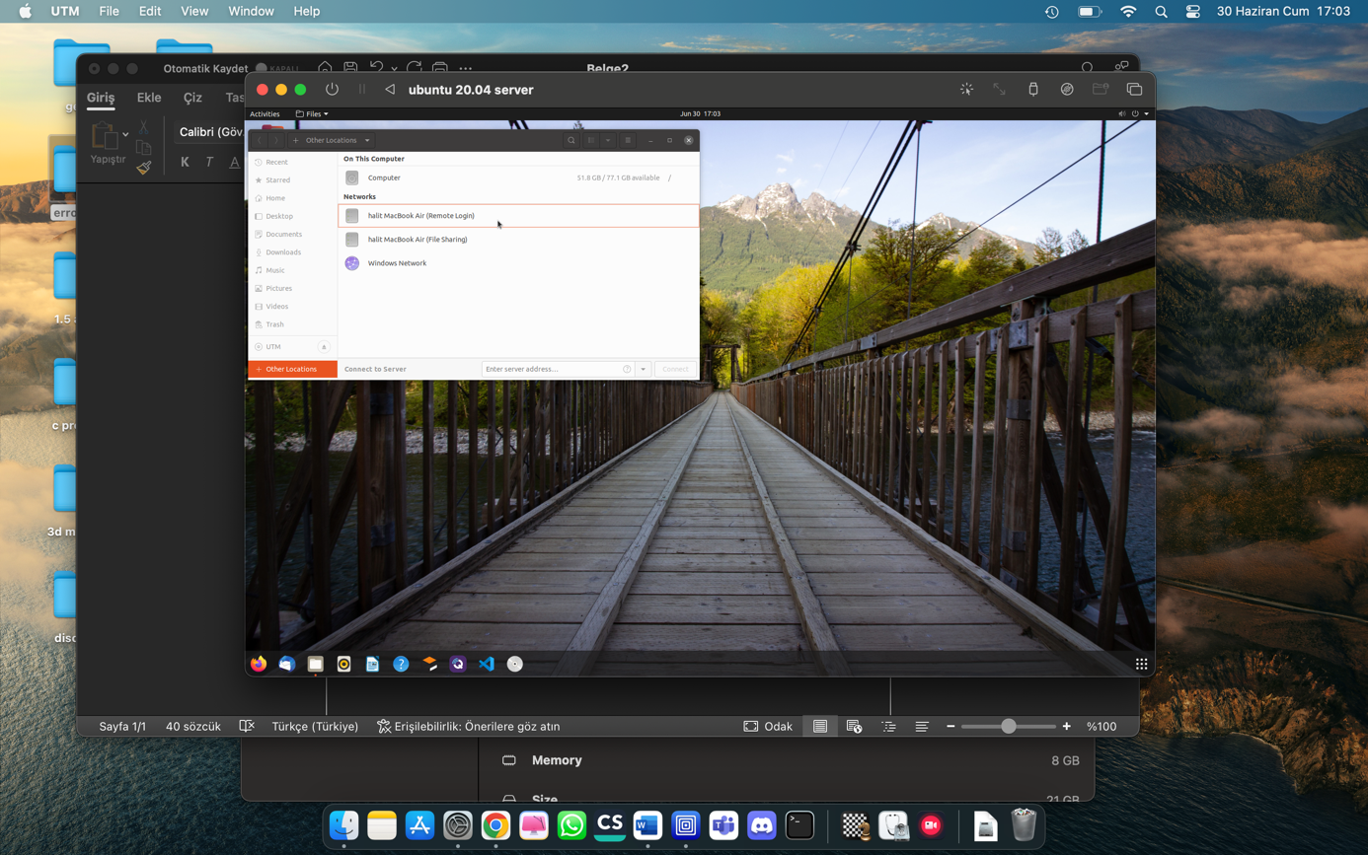

Login mac username and paswword

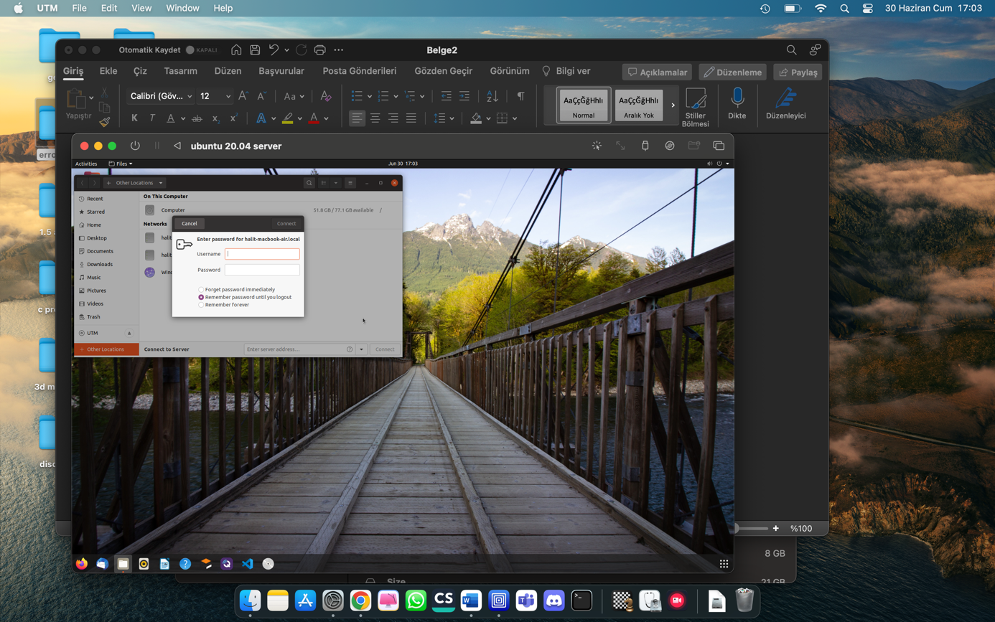

Mac files can be take on ubuntu and send file from ubuntu to mac